The review process includes the following steps (listed in order)
When applicable, emails from the system will specify end dates
Step Name | Approx. Timeframe
Start/End of First Quarter | March - April
2nd Quarter Update | July
3rd Quarter Update | October
4th Quarter &  Prepare for End of Year Evaluation | Mid-December –  Mid-January
End of Year Evaluation  (Supervisor Rating) | Mid-January –  Mid-February
Review Sign Off | Mid-late February

Click
or scan this QR code to access video tutorials:
System Access & Navigation
Login  Visit https://lehighes1.pageuppeople.com to access the PageUp system.  Log in using your Lehigh SSO user name and password.  Disable your internet browser pop-up blocker if needed. | 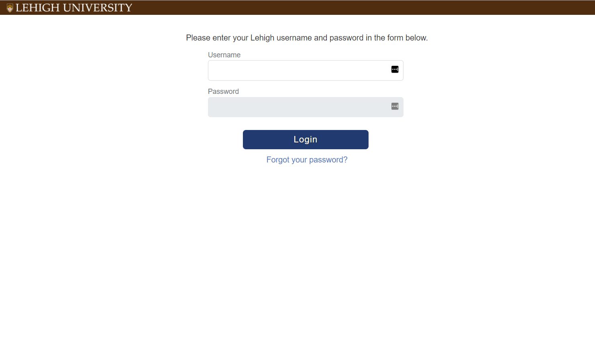
Accessing Your Team’s Current and Completed Forms  Under the My Team menu, select Performance Reviews.  Change status to All and click Search  Locate the review you want to access  From the “I want to” drop down:  - Click Open review, which will open the current review form in a new window  OR  - Select View the report to view, print, or download a PDF of a completed review | 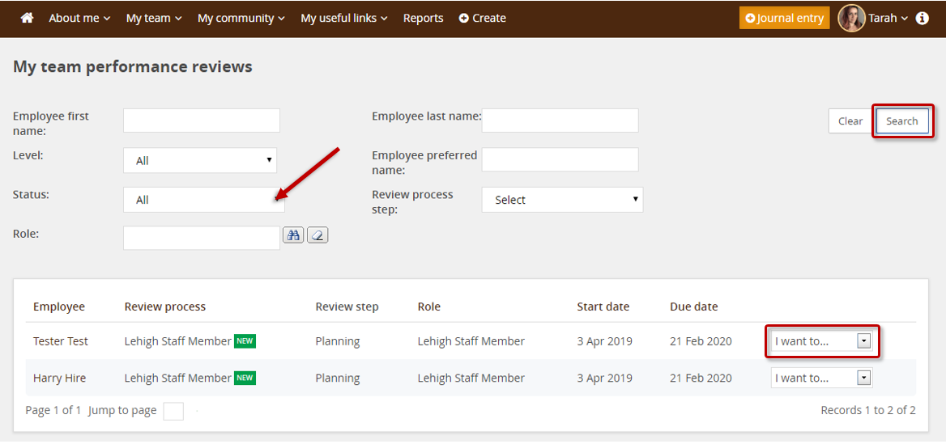
Accessing Current and Completed Forms,  Cont’d  Or, access your direct report’s current performance review from the Home Page by clicking the link in the green Team Performance Reviews section. | 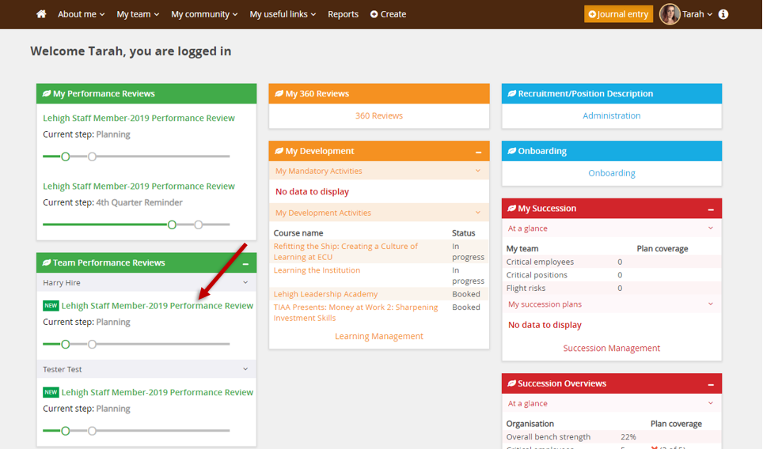
Navigation Bar (Section Types)
Click on a Section Type Title to access a section
-or-
Click the Next button at the bottom of the page to move to the next section type

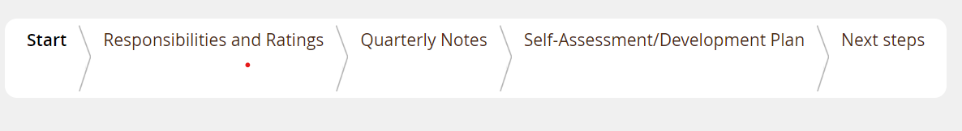
Start | Introductory/informational page to review at the beginning of each step
Responsibilities & Ratings | Section for storing and rating key accountabilities, goals, Lehigh’s Core Success Factors, and Lehigh’s Managerial Success Factors (when applicable)
Quarterly Notes | Section for entering and/or uploading notes from quarterly updates
Self-Assessment/ Development Plan | Contains Self-Assessment questions the employee answers to provide information and feedback for the manager; also lists upcoming and completed learning activities
Next Steps | Acknowledgement and overall rating section

Quarterly Updates (1st, 2nd, and 3rd)
Quarterly check-ins with your direct report are informal performance conversations that should cover three topics:  - review of expectations  - progress on goals  - opportunities for growth and development  The employee may enter check-in notes manually or upload them as an attachment into the appropriate box in the Quarterly Notes section of their form.  The PageUp system requires supervisor comments in this section, though this is not a required part of Lehigh’s process. | 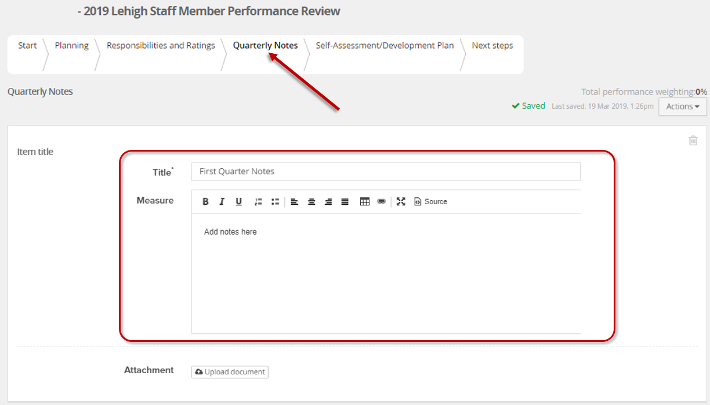
4th Quarter Update
This step includes preparing for the annual performance review
During the 4th Quarter step, your direct report is to complete the following in preparation for the annual performance review:  - Enter Accountabilities manually or upload a copy of the Position Description  - Enter or revise Goals  - Answer the Self-Assessment questions  No supervisor action is required during this step. | 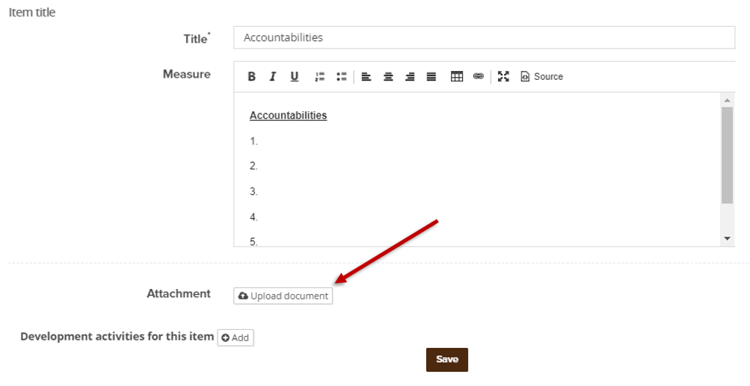  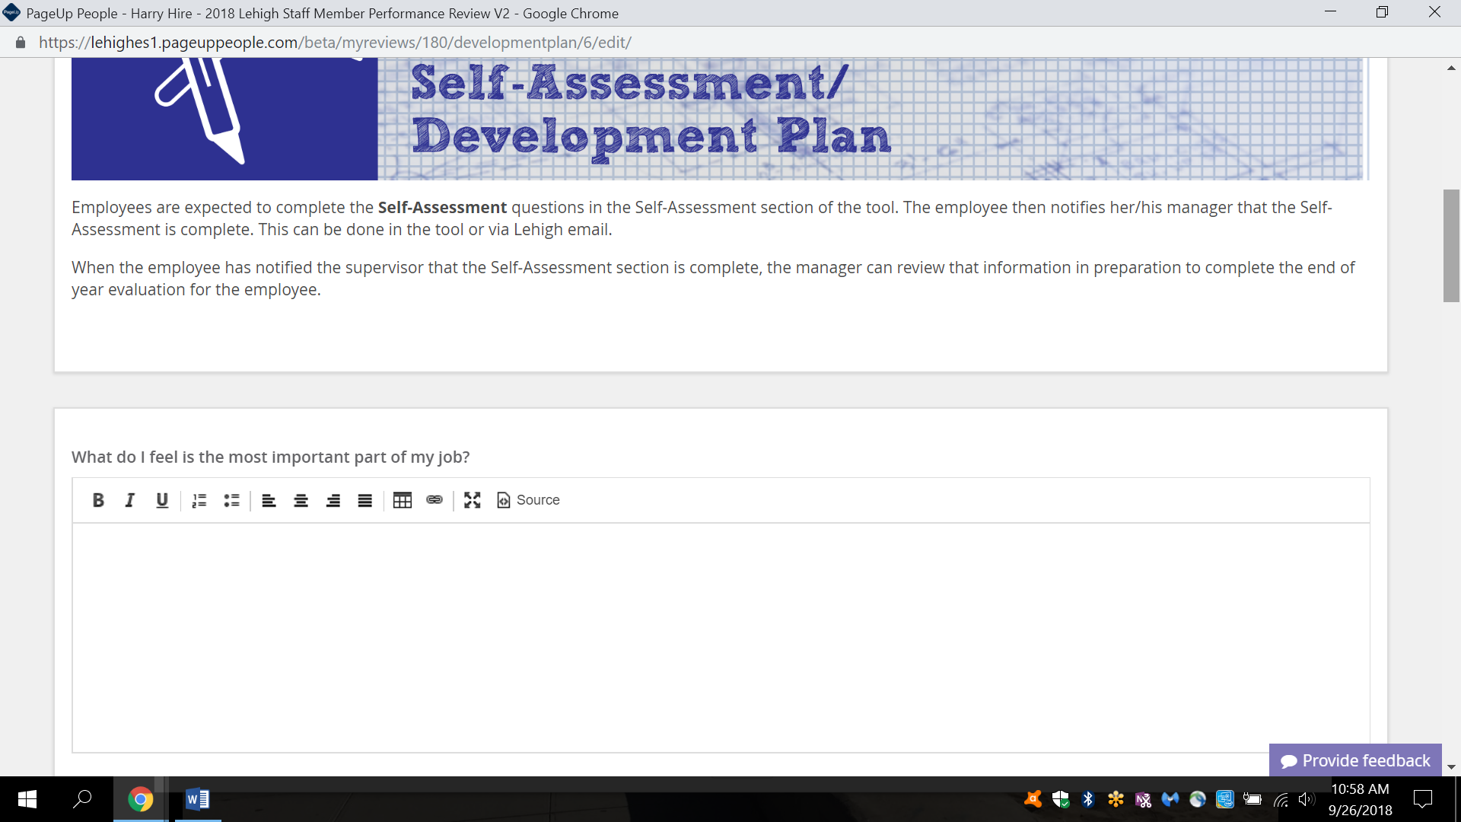
External Feedback Feature  This function is used to request performance feedback from individuals who are not the employee’s direct supervisor.  It can be useful in the event of a dual reporting structure, or may be used to solicit feedback from colleagues or others as appropriate.  Entries submitted via External feedback will embed directly into the Performance Review. | 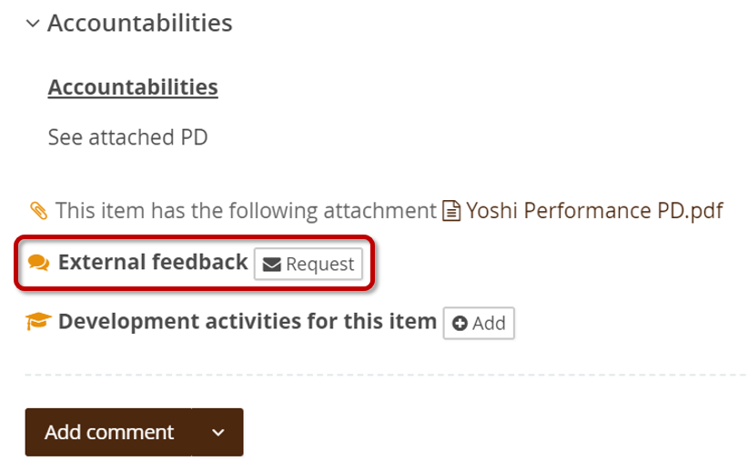  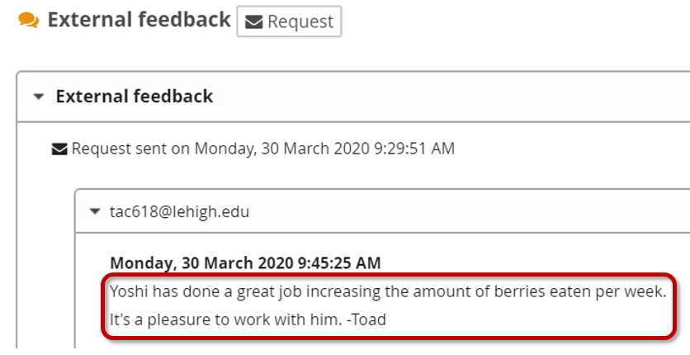
In order to transition the form to you for the End of Year Evaluation (Rating) step, your direct report must select the “Go to next step” button in the Next Steps section of their form. After doing so, they will not be able to make edits.
End of Year Evaluation (Rating)
Begin by reviewing the content within these sections:  - Quarterly Notes  - Self-Assessment/Development Plan  - Click the Completed tab to view  learning activity completions | 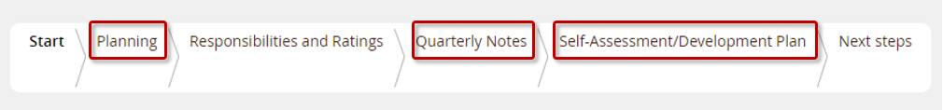  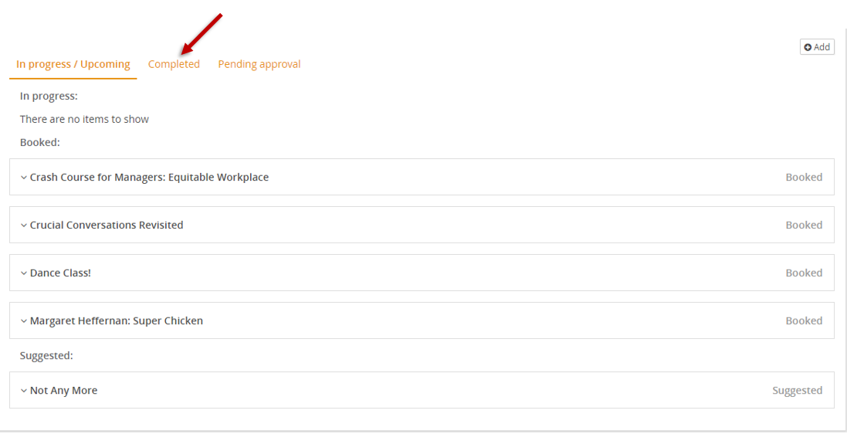
Navigate to the Responsibilities and Ratings section to review Accountabilities and Goals and assign ratings | 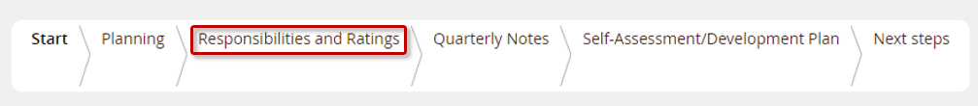
Assign star ratings for:  - Accountabilities  - Goals  - Lehigh’s Core Success Factors  - Lehigh's Managerial Success Factors  (if the employee manages exempt  or non-exempt staff) | Star Rating Criteria  Results are above and beyond expectations in a manner than is significant, extraordinary and rare  Results are consistent with complete mastery of all job expectations, including goals and behaviors (success factors)  Results meet all expectations (key accountabilities, goals and behaviors); a reliable and competent employee  Results demonstrate potential to become successful; some development and/or improvement is needed  Results significantly miss achievement of expectations; immediate improvement is required
Click Add comment to elaborate on your rating and provide additional feedback to the employee.  Supervisor comments are required for all star-rated items.  *Note: The PageUp system also requires supervisor comments in the Quarterly Updates section, though this is not a required part of Lehigh’s process. | 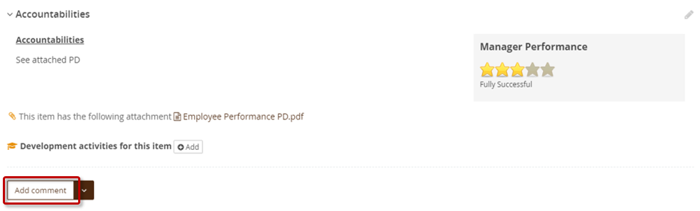
Comments do not save automatically.  Click Save & Share to post your comment to the review. Shared comments are visible to the employee.  Use the Save as Private option to add notes for yourself or to save a draft comment. These can be published or deleted later. To publish a draft comment, edit the comment then click Save & Share. | 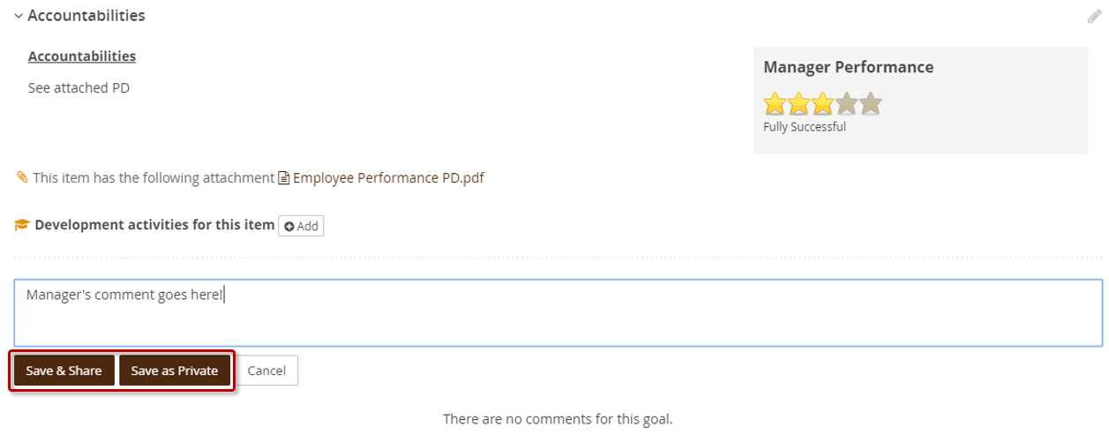
To link a journal entry or upload additional attachments to the review, use the dropdown button next to the Add comment button | 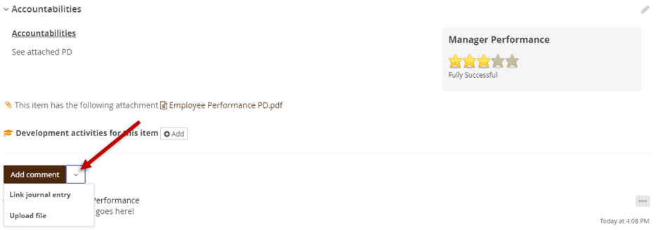
To enroll the employee in development activities from the Learning Library, click the Add button and select an activity. | 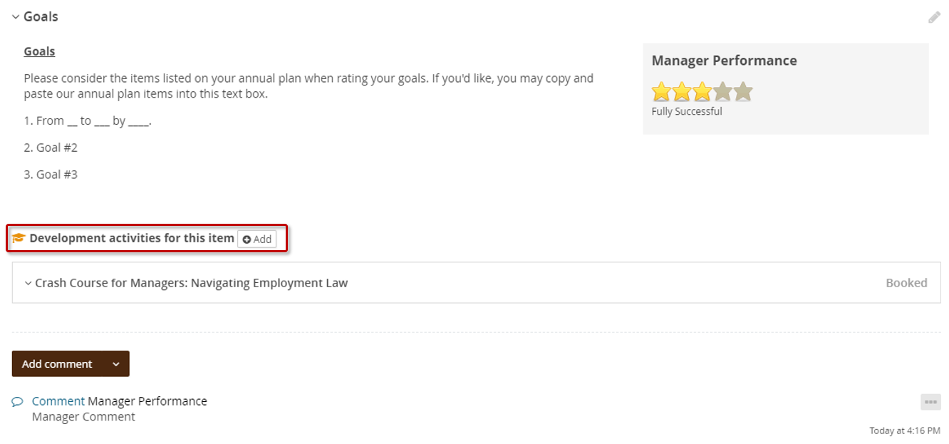
After assigning star ratings for Accountabilities, Goals, Lehigh’s Core Success Factors, and Lehigh's Managerial Success Factors (if applicable), and entering and saving your comments in all sections, navigate to the Next Steps section to assign the overall rating.
The form does not automatically calculate an overall rating. A one star/unsatisfactory rating displays until an overall rating is assigned.  - Assign the overall rating using the sliding scale  - Click Save  - Refresh the page (Ctrl+R) to ensure the Overall rating box matches the calibrated rating.  Note: The overall rating should align with stars assigned in the Responsibilities and Ratings section of the form. If you’ve assigned any one star (Unsatisfactory) or two star (Needs Improvement) ratings, please contact the performance management team in HR at inperf@lehigh.edu | 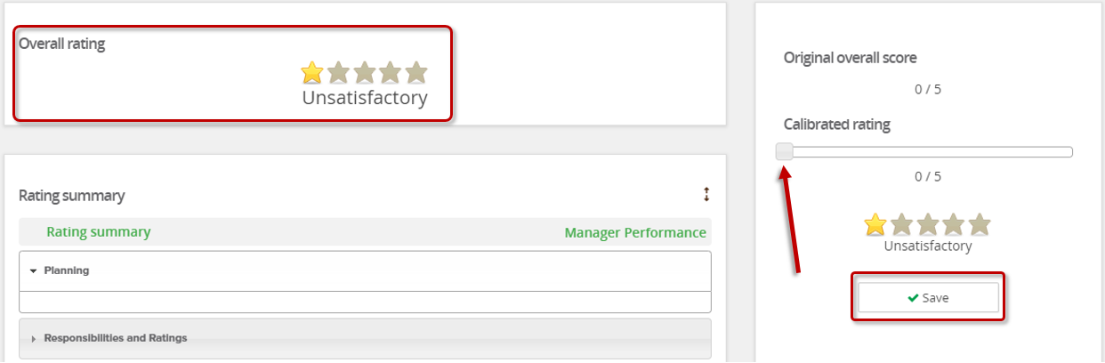
When the evaluation is complete, click Go to next step to send the form to the employee for review and acknowledgement.  Do NOT click Go to next step until the evaluation is completely finished. Clicking, ‘Go to next step’ will move this review to the next step and you will be unable to return to this step.” | 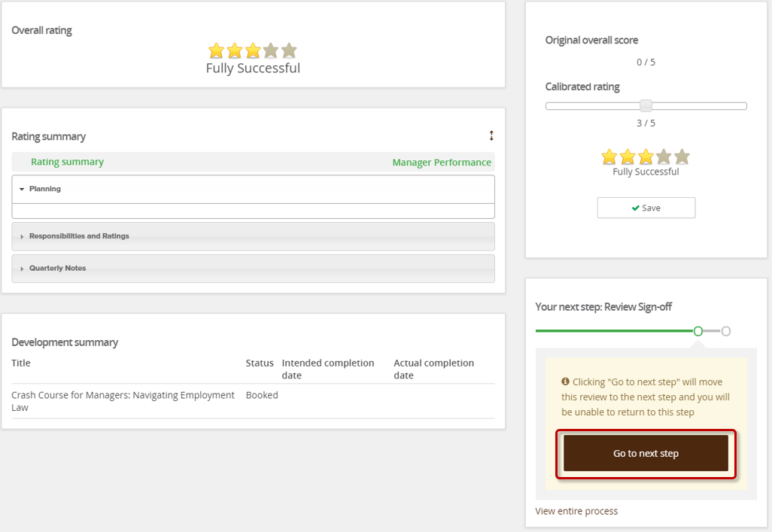
Note: If you click “Go to Next Step” and receive an error or are unable to progress the form:  - Review all information in the pink box at the top of the page. This is where the system defines what steps must be taken to move the form forward.  - The PageUp system requires comments in every comment field of the form, including the Quarterly Notes section.  - Lehigh's performance management process requires comments in the Responsibilities and Ratings section and Overall comments.  - You will need to enter "No comment" or "N/C" in the Quarterly Notes sections. | 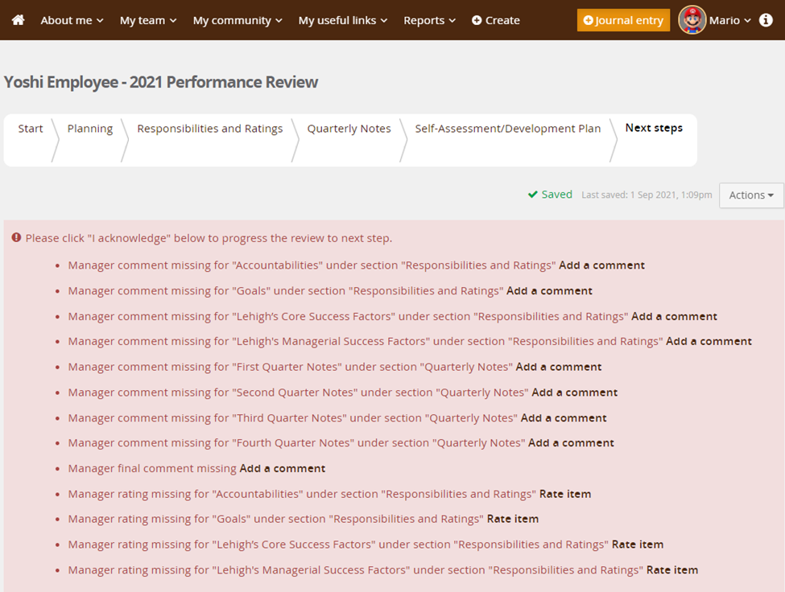

Review Sign-Off
Review all sections of the form for any additional employee comments before finalizing the review.  To add additional comments/responses (optional):  - Click Add comment  - Click Save & Share to publish the comment | 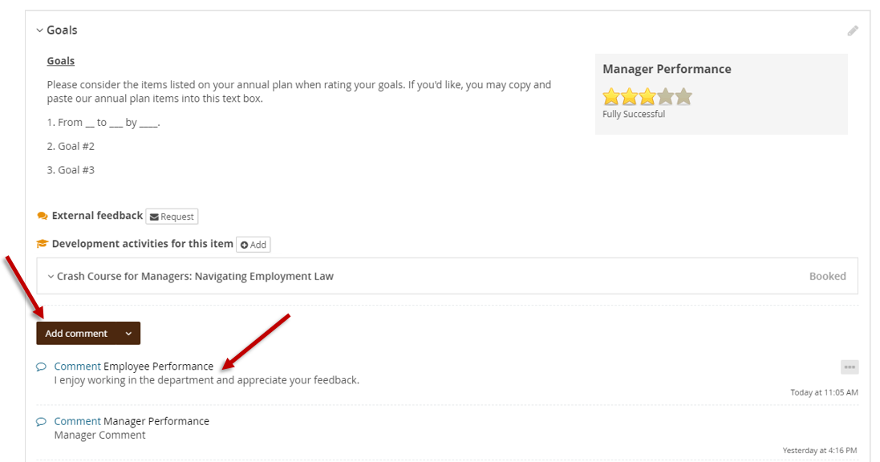
Navigate to the Next Steps section and click I acknowledge to finalize the review.  Selecting I acknowledge confirms the evaluation has been reviewed and discussed with the employee. | 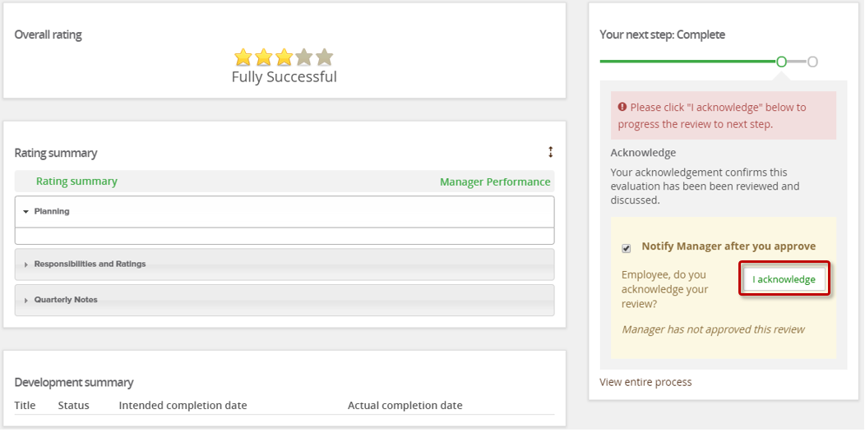
For additional references, visit https://hr.lehigh.edu/performance-review-process.
Contact inperf@lehigh.edu with questions or concerns.

