The review process includes the following steps (listed in order)
When applicable, emails from the system will specify end dates
Step Name | Approx. Timeframe
START/1st Quarter Update | March - April
2nd Quarter Update | July
3rd Quarter Update | October
4th Quarter &  Prepare for End of Year Evaluation | Mid-December –  Mid-January
End of Year Evaluation  (Supervisor Rating) | Mid-January –  Mid-February
Review Sign Off | Mid-late February

Click
or scan this QR code to access video tutorials:

System Access & Navigation
Login  Visit https://lehighes1.pageuppeople.com to access the PageUp system.  Login using your Lehigh SSO user name and password.  Disable your internet browser pop-up blocker if needed. | 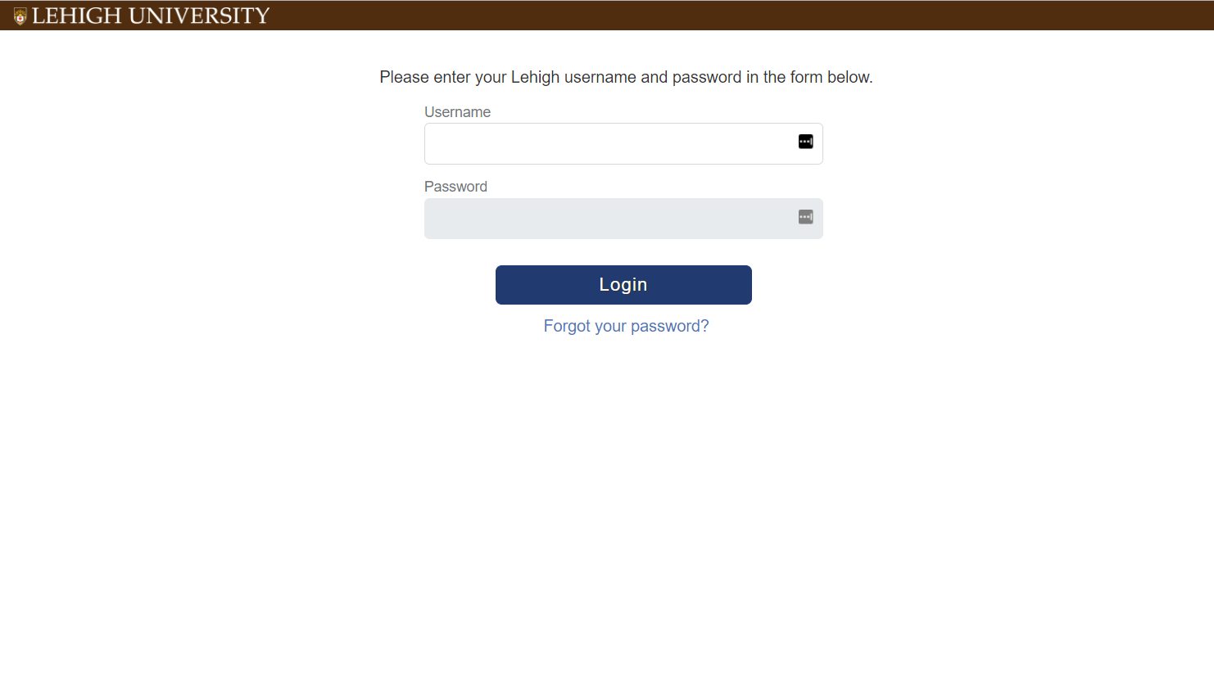
Accessing Current and Completed Forms  Under the About Me menu, select Performance Reviews.  Change status to All and click Search  Locate the review you want to access  From the “I want to” drop down:  - Click Open review, which will open the current review form in a new window  OR  - Select View the report to view, print, or download a PDF of a completed review | 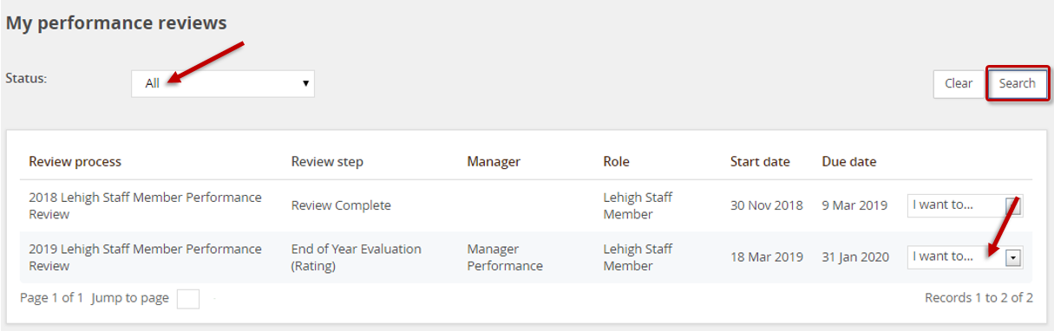
Accessing Current and Completed Forms,  Cont’d.  Or, access your current performance review from the Home Page by clicking the link in the green My Performance Reviews section. | 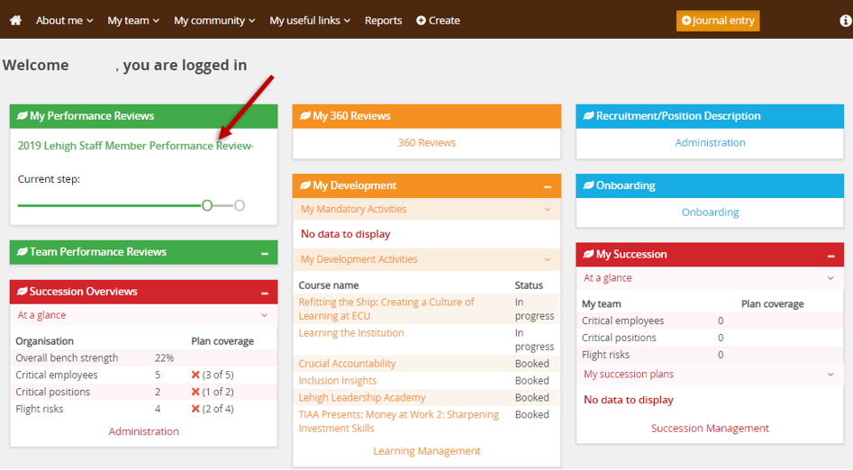
Navigation Bar (Section Types)
Click on a Section Type Title to access a section
-or-
Click the Next button at the bottom of the page to move to the next section type

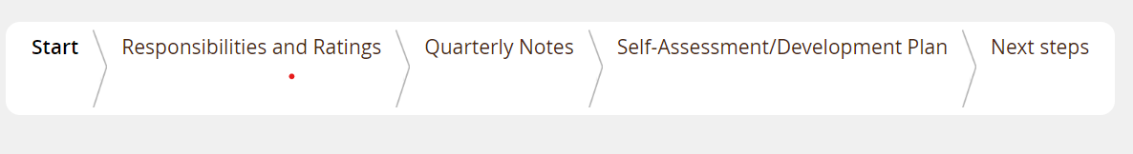
Start | Introductory/informational page to review at the beginning of each step
Responsibilities & Ratings | Section for storing and rating your key accountabilities (PD), goals, Lehigh’s Core Success Factors, and Lehigh’s Managerial Success Factors (when applicable)
Quarterly Notes | Section for entering and/or uploading notes from quarterly updates with your manager
Self-Assessment/ Development Plan | Questions that provide important information/feedback for your supervisor prior to their completion of the annual performance review
Next Steps | Acknowledgement and overall rating section

Quarterly Updates (1st, 2nd, and 3rd)
Quarterly check-ins with your supervisor are informal performance conversations that should cover three topics:  - review of expectations  - progress on goals  - opportunities for growth and development  Notes from a check-in may be entered or uploaded as an attachment into the appropriate box in the Quarterly Notes section. | 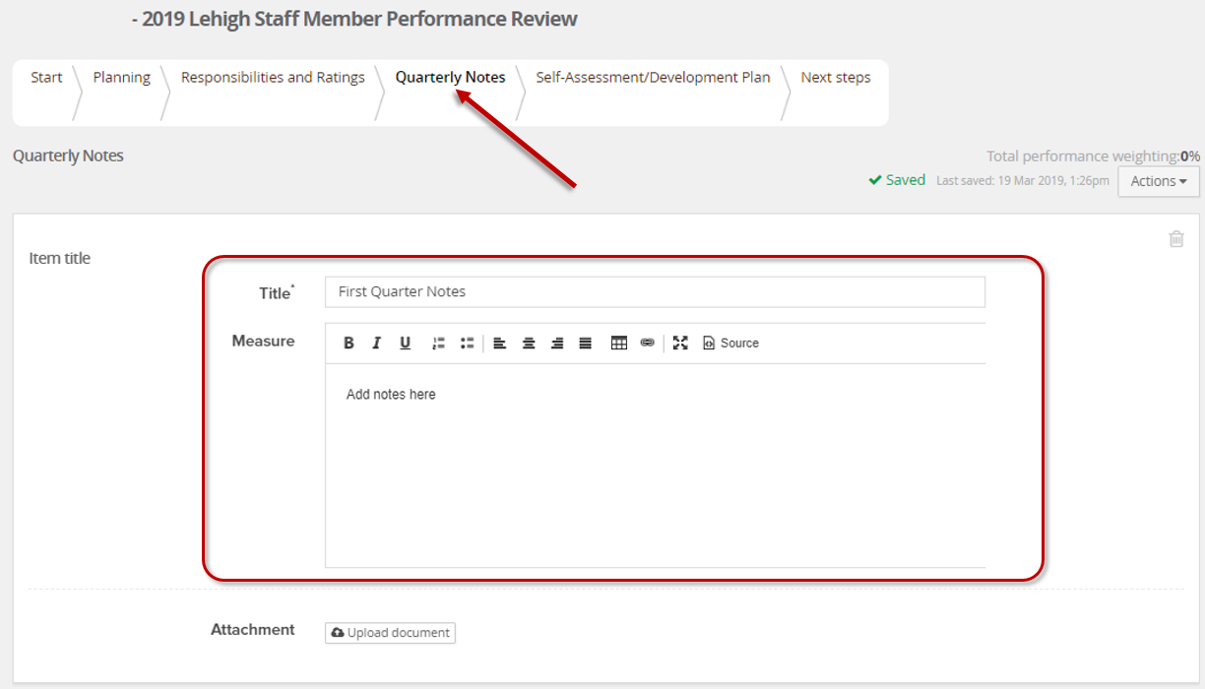
4th Quarter Update / Preparing for the Annual Performance Review
This step includes preparing for the annual performance review, as outlined below
Responsibilities and Ratings Section
Accountabilities  Enter your accountabilities into the box or use the Upload Document button to attach a copy of your Position Description  Visit this link to access instructions for viewing/downloading your Position Description. | 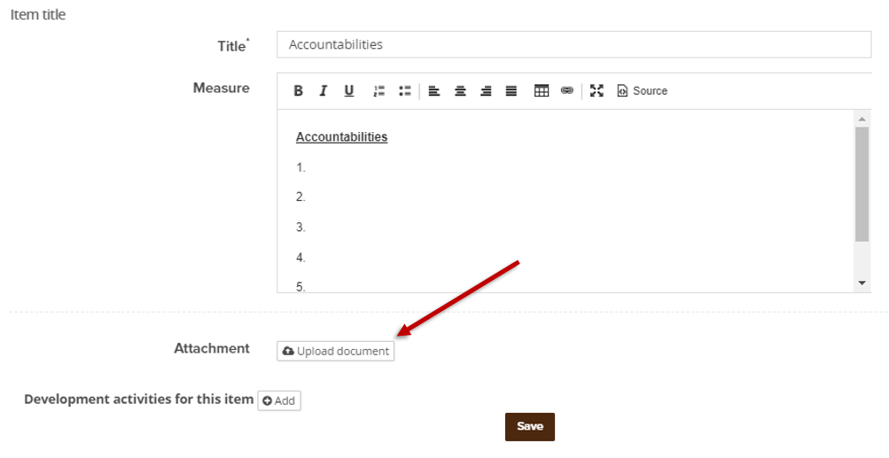
Goals  - Enter your goals into the box or use the Upload Document button to attach a document.  - To attach more than one document, first click Save, then click  and select Upload file  - Optional: click Link journal entry to search for and link journal entries to the review | 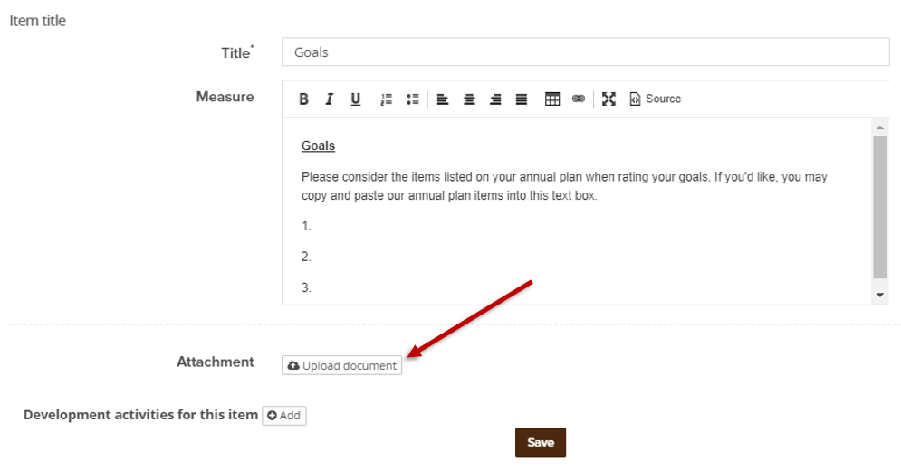  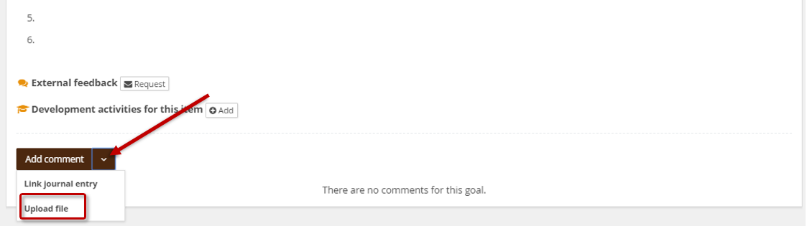
Lehigh’s Core Success Factors  This box cannot be modified, but an attachment can be added. | 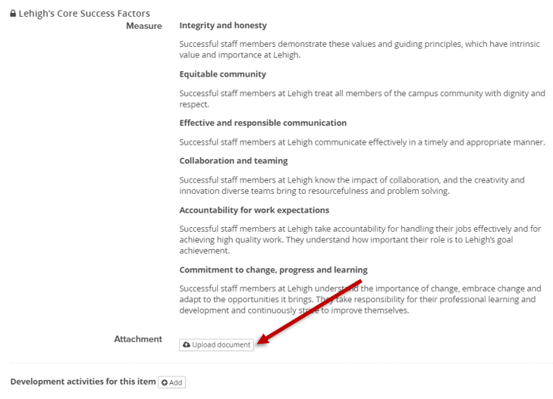
Lehigh's Managerial Success Factors  I For managers only  If you do not manage exempt or non-exempt staff, click then OK to delete this box. | 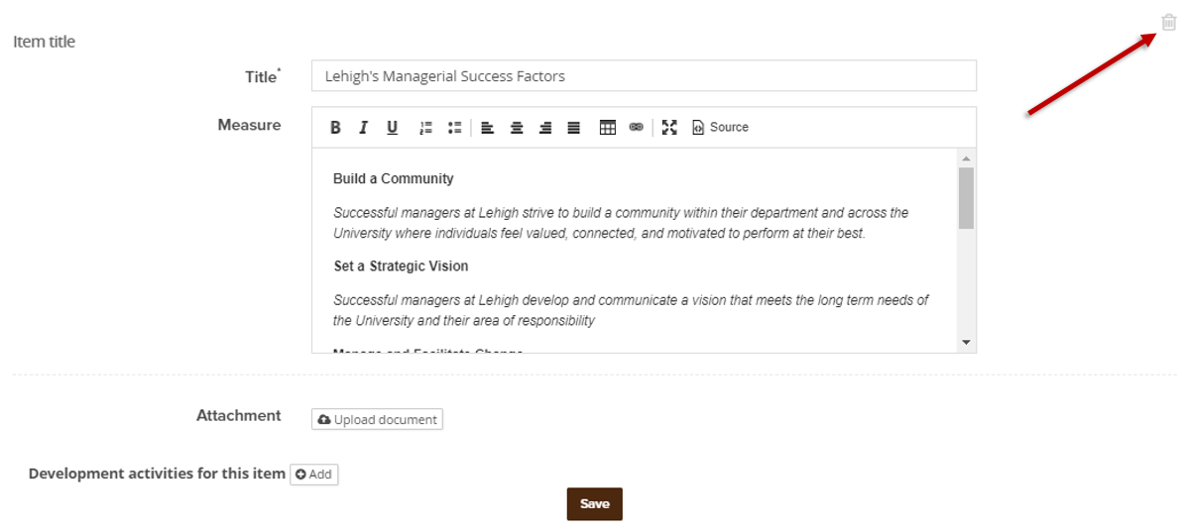
Self-Assessment Section
This section contains seven self-assessment questions.  Your answers to these questions provide your supervisor with important information for completing your review. | 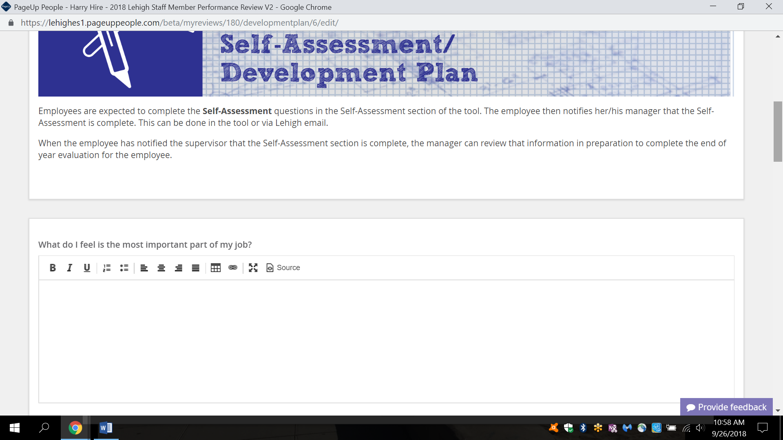
Next Steps Section
After completing all steps, navigate to the Next Steps section and select the Go to Next Step button.  Clicking “Go to next step” will transition the form to your supervisor for the End of Year Evaluation (Rating) and you will not be able to make edits. |  | 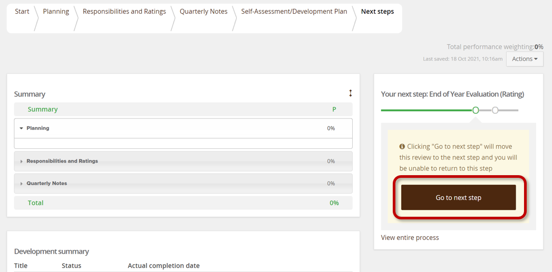
Review Sign-Off
This step occurs after your supervisor completes the End of Year Evaluation (Rating).
Review all sections of the form for your manager’s comments and ratings.
The Responsibilities and Ratings section contains your ratings for Key Accountabilities, Goals, Lehigh’s Core Success Factors, and Lehigh’s Managerial Success Factors (if applicable) | 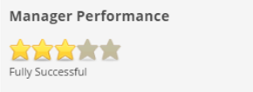
To add additional comments/responses (optional) click Add Comment button  Click Save & Share to publish the comment. Shared comments are visible to your manager. | 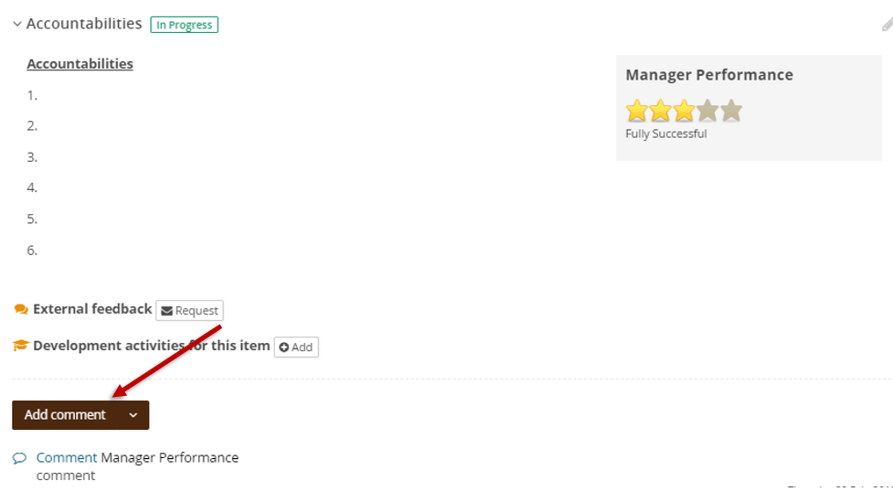  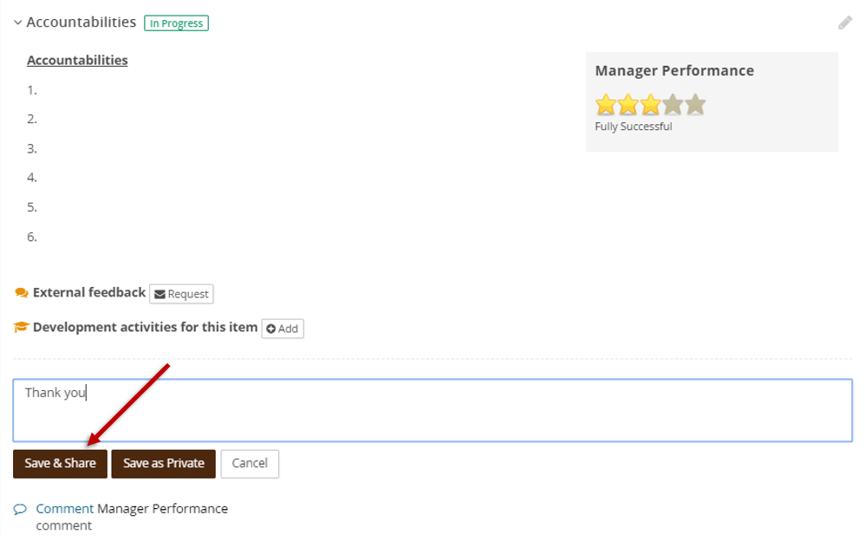
Navigate to the Next Steps section to view your overall rating and acknowledge your review.  Selecting “I acknowledge” confirms the evaluation has been reviewed and discussed with you. | 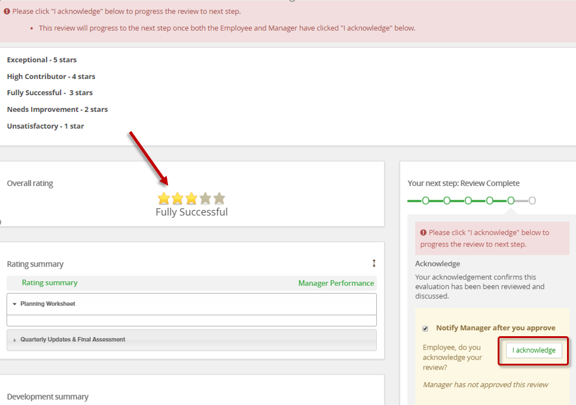
For additional references, visit https://hr.lehigh.edu/performance-review-process.
Contact inperf@lehigh.edu with questions or concerns.

